**01. Microservices Canary Deployment - Introduction**

--- we are going to understand what are micro services canary deployments and in this entire section, we are also going to do the canary deployment of our applications in EKS cluster.

**What are canary deployments…?**

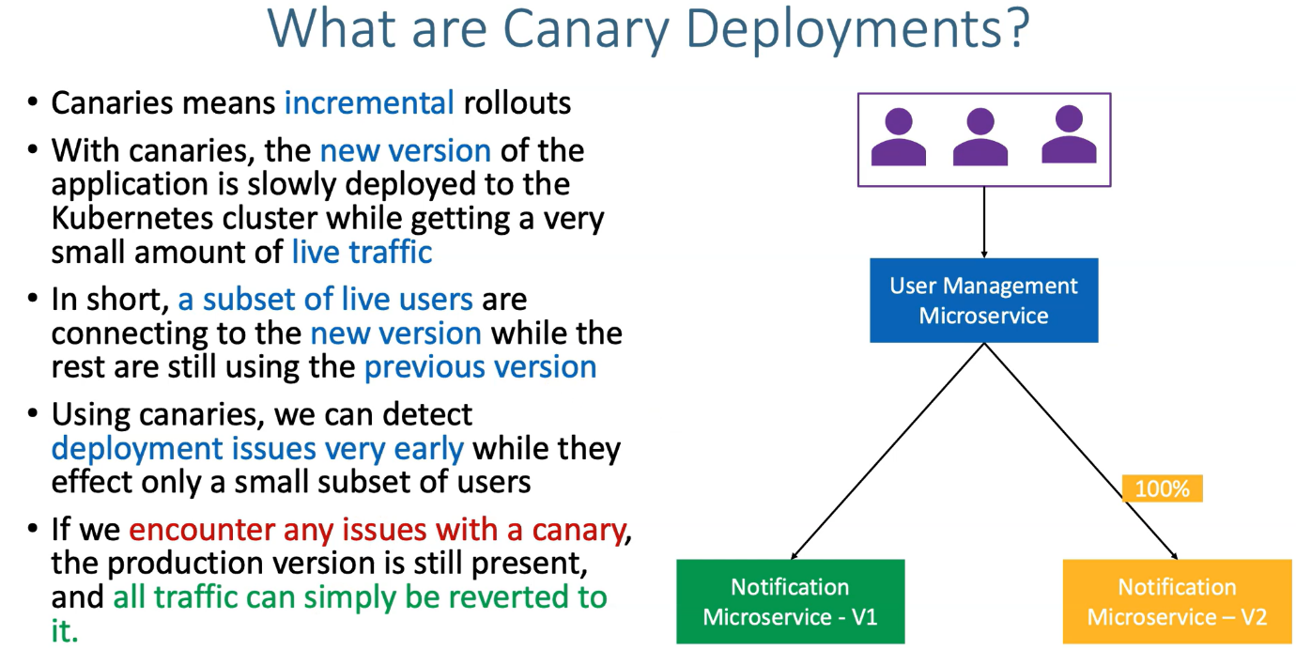

**Microservice canary deployment**

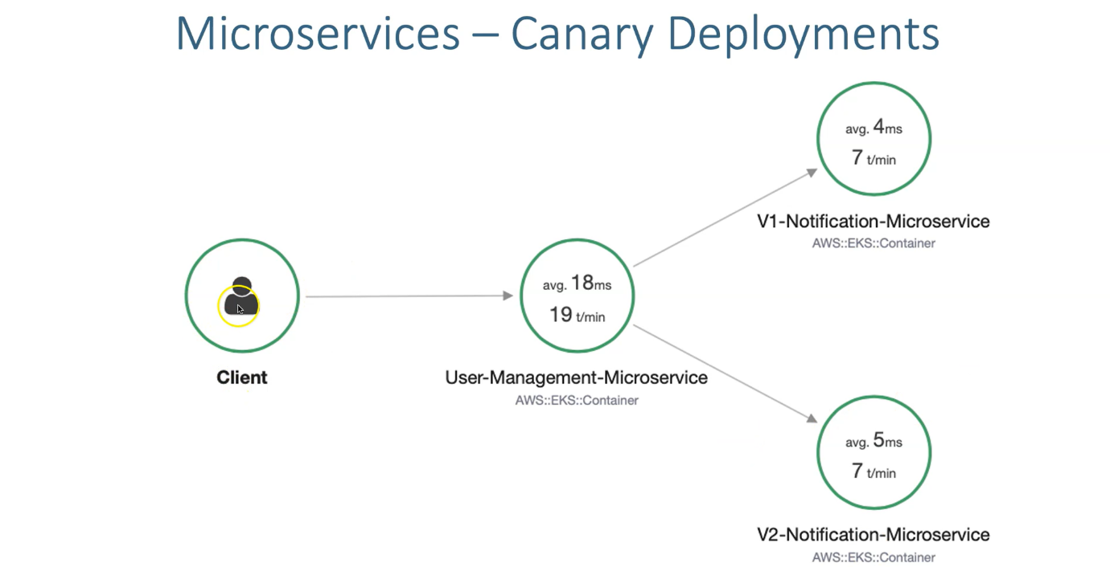

--- So once we perform our canary deployment and then if we go back to x ray and then see it. So, it is going to look like above diagram.

--- client as a user, when you access user management microservices and then a few of traffic will go to v1-notification microservice and then few traffic will go to v2-notification microservice.

--- let's see that in GitHub repository, what we have planned for this entire section.

So we are in Arab bliss egress cubin.

It is master class and we are entering over 14 Microsoft offices, cannery deployment S..

Right.

So we already discussed about the use case.

Right.

So we are going to from user management up microcircuits.

We are going to call both versions of notification micro services that use case.

And we can distribute our Tophet to you and then we to build on the number of the replicas we configure

on our respective deployment files.

So Notification Service V1 will have one deployment and then a NSV two will help one more deployment.

So example, if you configure for replay course in and NSB one deployment file, which is nothing.

But let me open the visual studio Korto in Visual Studio Code.

You'll see that we have something called notification deployment and then reto notification deployment.

So this is notification deployment, even notification micro service.

And this is V2 notification, micro service in notification deployment.

If you send replicas to here and then for V two also to then, which is nothing, but you are distributing

the traffic 50 percent to a necessary to washin and then 50 percent do.

And this one version.

So like this, by altering the number of replicas between two deployments, you can have that Cannady

successfully implemented with out of the box in micro services.

So on Cuban it is sort of the box with whatever the availability we have with basic deployments, we

can do it without using any external service is currently not currently like we didn't deploy them on

what Cuban or diskless that like is to your data BLIS app, MESHAD, whatever it is.

OK, so we know our demo.

So we are going to do it with 50 percent traffic too, unless we do.

And then 50 percent traffic to and that's V1.

So the list of Docker images we are going to use here is user management service, the same one which

is 3.000 BLIS x ray with my Eskil VB and we are going to use notification Micra service Vivaan and this

should be V2.

I should update this one is going to be 3.000 erodable s x ray and V2 is going to be 4.0 or zero Iblis

x ray.

So this completes the introduction part of our micro services.

Cannady deployments and the next lecture will focus on the prerequisites for this respect to section